SURVEY ON CLOUD AUTHENTICATION USED BY SME’S

A PROJECT REPORT

Submitted by

Jeavi karwal (24BCY70002) Vanshdeep Singh (24bcy70033)
Harkunwar singh (24bcy70049) Manya sharma (24bcy70050)
Amitoz singh (24bcy70071)

in partial fulfillment for the award of the degree of

BACHELOR OF ENGINEERING
IN

COMPUTER SCIENCE

Chandigarh University


MAY 2023

BONAFIDE CERTIFICATE

Certified that this project report “Survey on cloud authentication using sme’s” is the Bonafide work of “Jeavi Karwal , Vanshdeep Singh, Harkunwar Singh, Manya Sharma, Amitoz Singh” who carried out the project work under my/our supervision.

SIGNATURE

Dr. Aman Kaushik

HEAD OF THE DEPARTMENT

A.I.T (c.s.e)

SIGNATURE

Dr. Sayed Irfan Yakoob

SUPERVISOR

A.I.T (c.s.e)

Submitted for the project viva-voce examination held on

INTERNAL EXAMINER EXTERNAL EXAMINER
TABLE OF CONTENTS
Section No. | Title | Page No.
— | List of Figures | 5
— | Abstract | 6
— | Graphical Abstract | 7
— | Abbreviations | 8–9
— | Symbols | 10–11
CHAPTER 1 | INTRODUCTION | 12–18
1.1 | Client Identification / Need Identification | 12
1.2 | Identification of the Problem | 13
1.3 | Task Identification | 14
1.4 | Timeline | 14–17
1.5 | Organization of the Report | 17
1.6 | Significance of the Study | 17–18
1.7 | Scope of the Study | 18
1.8 | Limitations of the Study | 18
1.9 | Relevance to Industrial & Academic Environments | 18
1.10 | Impact of Poor Authentication Practices | 18
1.11 | Extended Timeline Breakdown | 18
1.12 | Expanded Organization of the Report | 18
CHAPTER 2 | LITERATURE REVIEW / BACKGROUND STUDY | 19–25
2.1 | Timeline of the Reported Problem | 19
2.2 | Proposed Solutions by Researchers and Industry | 19–21
2.3 | Bibliometric Analysis | 21–22
2.4 | Review Summary | 22
2.5 | Problem Definition | 22
2.6 | Goals / Objectives | 22–23
2.7 | Global Perspective on Authentication Trends | 23
2.8 | National SME Context | 23–24
2.9 | Gaps Identified in Literature | 24
2.10 | Theoretical Framework | 24–25
2.11 | Extended Problem Definition | 25
2.12 | Additional Objectives | 25
CHAPTER 3 | DESIGN FLOW / PROCESS | 26–35
3.1 | Concept Generation | 26
3.2 | Evaluation & Selection of Specifications | 26–27
3.3 | Design Constraints | 27–28
3.4 | Feature Finalization Based on Constraints | 28
3.5 | Design Flow (Alternative Designs) | 28–29
3.6 | Best Design Selection | 29
3.7 | Implementation Plan / Methodology | 29–35
3.8 | Tools & Platforms Used | 35
3.9 | Ethical Considerations | 35
3.10 | Risk Assessment | 35
3.11 | Survey Question Categories | 35
3.12 | Data Validation Techniques | 35
3.13 | Extended Comparison of Designs | 35
3.14 | Workflow Diagram | 35
3.15 | Summary of Design Flow | 35
CHAPTER 4 | CONCLUSION & FUTURE WORK | 36–42
4.1 | Implementation of Survey & Data Collection | 36
4.2 | Results & Key Findings | 36–37
4.3 | Analysis | 37
4.4 | Validation | 37
4.5 | Sector-Wise Comparative Results | 37–38
4.6 | Detailed Data Interpretation | 38–39
4.7 | Identification of Vulnerabilities | 39
4.8 | Correlation Between SME Size & Adoption | 39–40
4.9 | Validation Through Industry Reports | 40–41
4.10 | Extended Analysis Summary | 41
4.11 | Additional Validation Techniques | 41–42
— | References | 43
— | Appendix (Survey Questionnaire) | 44–48
— | User Manual | 48–54

List of Figures
FIGURE | PAGE NO.
1.1 | 7
1.2 | 50
1.3 | 50
1.4 | 51
1.5 | 51
1.6 | 52
1.7 | 52
1.8 | 53
1.9 | 53
1.10 | 54
1.11 | 54

ABSTRACT
Small and Medium-Scale Enterprises (SMEs) across India are rapidly adopting digital platforms for business operations, customer management, payments, and internal workflows. With this growth, the security of digital assets has become a critical concern, especially as cyberattacks targeting SMEs have increased in both frequency and sophistication. Authentication, being the first line of defence in cybersecurity, plays a vital role in ensuring that only authorized individuals can access sensitive systems and information. Despite this importance, many SMEs continue to rely on outdated or weak authentication practices due to limitations in budget, technical expertise, and awareness of modern security solutions.
This project presents a comprehensive survey-based analysis of the authentication methods used by SMEs and evaluates the strengths, weaknesses, and security gaps associated with them. The study includes both qualitative and quantitative data collected from SMEs operating in manufacturing, retail, education, and service sectors. A structured questionnaire was used to understand factors such as reliance on passwords, adoption of multi-factor authentication (MFA), usage of biometric systems, and attitudes toward advanced authentication technologies.
The results indicate that although passwords remain the dominant authentication method due to convenience and low cost, they are also the primary cause of security vulnerabilities such as password reuse, weak password practices, and lack of regular updates. Only a small portion of SMEs have implemented MFA or biometric authentication, largely due to perceived complexity and cost. The findings highlight a clear gap between the security needs of SMEs and the authentication mechanisms currently in use.[2]
This study concludes that while SMEs recognize the importance of authentication, there is a pressing need for awareness, cost-effective security solutions, and simplified methods of implementing modern authentication technologies. The project further suggests actionable recommendations tailored for SMEs, including lightweight MFA solutions, employee training programs, and gradual transitions to stronger authentication ecosystems. This survey provides valuable insights that can guide SMEs, cybersecurity practitioners, and policymakers in improving authentication security in resource-limited environments.

GRAPHICAL ABSTRACT
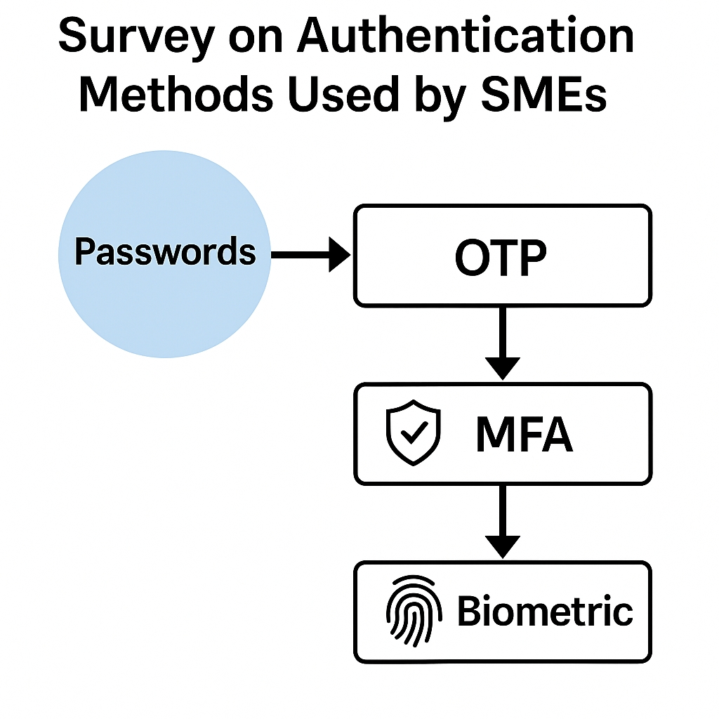
Figure 1.1

ABBREVIATIONS

SME – Small and Medium-Scale Enterprise
MFA – Multi-Factor Authentication
2FA – Two-Factor Authentication
OTP – One-Time Password
IAM – Identity and Access Management
UI – User Interface
API – Application Programming Interface
SSO – Single Sign-On
PIN – Personal Identification Number
UID – User Identification Number
DBMS – Database Management System
DoS – Denial of Service
NIST – National Institute of Standards and Technology
AI – Artificial Intelligence
ML – Machine Learning
IAM – Identity and Access Management: A framework of policies and technologies used to ensure that the right individuals have appropriate access to organizational systems, applications, and data.
SSO – Single Sign-On: An authentication method that allows users to log in once and gain access to multiple applications or services without repeated credential entry.
OTP – One-Time Password: A temporary password valid for a single login session or transaction, commonly used as a second factor in MFA solutions.
U2F – Universal 2nd Factor: A hardware-based authentication standard that enhances security by requiring a physical security key in addition to passwords.
PKI – Public Key Infrastructure: A system that manages digital certificates and cryptographic keys to secure communications and verify user identities.
TLS – Transport Layer Security: A cryptographic protocol used to secure communications over networks, ensuring data integrity and confidentiality.
SSP – Security Service Provider: A vendor or third-party service offering cybersecurity solutions, including authentication and identity management services for SMEs.
IdP – Identity Provider: A system or service that creates, maintains, and manages identity information and provides authentication services within digital environments.
SAML – Security Assertion Markup Language: An open standard used for exchanging authentication and authorization data between identity providers and service providers, often used in enterprise SSO systems.
RBAC – Role-Based Access Control: A method of restricting system access based on user roles within an organization, helping SMEs maintain structured permission levels.
ABAC – Attribute-Based Access Control: An advanced access control model that assigns permissions based on a combination of user attributes, environmental conditions, and resource characteristics.
TOTP – Time-Based One-Time Password: A dynamic code generated at regular time intervals, used to strengthen MFA by requiring a time-synchronized second factor.
HSM – Hardware Security Module: A tamper-resistant hardware device used to generate, store, and protect cryptographic keys essential for secure authentication.
UEBA – User and Entity Behavior Analytics: A security approach that monitors user behaviour to detect anomalies, insider threats, and suspicious access patterns.
IAMM – Identity and Access Management Maturity: A measurement model that evaluates the progress, capabilities, and sophistication of an organization’s authentication and identity management practices.
BYOD – Bring Your Own Device: A workplace policy that allows employees to use personal devices for business activities, increasing the need for strong authentication controls.
EDR – Endpoint Detection and Response: A cybersecurity solution focused on monitoring endpoints to detect and respond to suspicious authentication or access-related behaviour.
ATP – Advanced Threat Protection: A suite of technologies designed to prevent, detect, and respond to sophisticated cyberattacks that target authentication systems and user
SYMBOLS
Symbol | Description
% | Percentage — used in survey statistics, response rates, and adoption metrics
↑ | Increase or upward trend in authentication adoption
↓ | Decrease or downward trend in usage or security incidents
→ | Directional flow indicator used in diagrams and processes
← | Reverse flow indication in comparative diagrams
↔ | Bidirectional relationship or comparison between two authentication methods
✓ | Verification, correctness, or successful authentication
✕ | Incorrect entry, failed authentication, or error condition
* | Bullet mark used to denote emphasis or footnotes
# | Numerical index or identifier used in tables and figures
⌧ | Security risk or vulnerability indicator in diagrams
⌁ | Represents a data connection or communication link
⌂ | Represents a system boundary (e.g., SME internal network)
⊗ | Denial of access or authentication rejection
∆ | Change or variation in security adoption level
Σ | Summation of survey responses or aggregated data
μ | Mean value used in statistical interpretation (if applicable)
λ | Rate or frequency of security incidents (optional statistical notation)
≈ | Approximately equal (used for approximate data values)
≥ | Greater than or equal to (used in analysis comparisons)
≤ | Less than or equal to (used in findings summaries)

INTRODUCTION

1.1 Client Identification / Need Identification / Relevant Contemporary Issue

Small and Medium-Scale Enterprises (SMEs) form the backbone of India’s industrial and service sectors. As these enterprises increasingly adopt digital tools—such as cloud applications, online payment systems, ERP solutions, and small-scale digital infrastructures—the need for stronger authentication mechanisms has become more critical than ever.

Cybersecurity reports from national and international agencies highlight that SMEs are more vulnerable to cyberattacks due to limited budgets, lack of dedicated IT teams, and minimal awareness about modern authentication solutions. Most data breaches reported in SMEs result from weak or compromised credentials, password reuse, or lack of multi-layer authentication.[2]

In this context, understanding the current authentication practices used by SMEs, assessing the security risks associated with them, and identifying practical ways to enhance authentication becomes a pressing need. This mini-project focuses on addressing this need by conducting a structured survey among SMEs.

1.2 Identification of the Problem

Although digital adoption among SMEs is growing rapidly, their security practices—especially user authentication—have not progressed proportionately. Many SMEs continue using traditional username-password combinations that are easy to guess, reuse, or compromise.

Preliminary exploration reveals the following problems:

Over-reliance on passwords without additional layers of security

Limited adoption of Multi-Factor Authentication (MFA)

Lack of awareness about biometric or passwordless authentication

Minimal security training for staff handling digital systems

No periodic evaluation of authentication mechanisms

Thus, the identified problem is:

“SMEs are using outdated or insufficient authentication methods, making their systems vulnerable to unauthorized access and cyber threats.”

1.3 Task Identification

To address the above problem, several systematic tasks were identified and executed:

1.3.1 Task 1 – Survey Design

Creation of a structured questionnaire

Identification of key focus areas: password usage, MFA adoption, biometrics, security awareness

1.3.2 Task 2 – Data Collection

Selection of SMEs from retail, service, manufacturing, and education sectors

Distribution of the survey through online and offline modes

Recording of responses in a structured dataset

1.3.3 Task 3 – Data Analysis

Categorization of authentication methods used

Statistical interpretation of adoption levels

Identification of gaps and security concerns

1.3.4 Task 4 – Recommendation Development

Evaluation of feasible authentication improvements

Creation of suggestions tailored to SME budgets and skill levels

1.3.5 Task 5 – Report Preparation

Formal documentation of findings

Creation of diagrams, tables, and visual representations

Compilation of results into the final mini-project report

1.4 Timeline

The following timeline represents the duration of the project (4 weeks), structured like a Gantt chart in textual form:

Week 1: Problem study, background research, survey questionnaire design

Week 2: Circulating the survey to SMEs, collecting responses

Week 3: Data analysis, comparison of authentication practices, graph generation

Week 4: Report writing, graphical abstract creation, proofreading, and final submission preparation

1.5 Organization of the Report

This report is organized into five chapters:

Chapter1 – Introduction
Provides background, identifies the problem, outlines tasks, timeline, and structure of the report.

Chapter 2 – Literature Review
Discusses global and national research on authentication methods, prior solutions, bibliometric analysis, and the formal problem definition.

Chapter 3 – Design Flow / Process
Covers feature identification, constraints, alternative designs, best design selection, and survey methodology.

Chapter 4 – Results Analysis and Validation
Presents survey outcomes, charts, tables, trend analysis, and validation using modern tools.

Chapter 5 – Conclusion and Future Work
Summarizes major findings, deviations, and provides recommendations for future improvements in SME authentication practices.
1.6 Significance of the Study
The study holds immense relevance in the rapidly digitizing SME ecosystem of India. As SMEs increasingly depend on digital solutions for customer engagement, inventory management, online payments, and cloud-based data storage, the importance of robust authentication grows proportionately. This project not only examines current practices but also evaluates their long-term implications on operational security and business sustainability.
Several SME owners and managers shared insights indicating that authentication weaknesses often go unnoticed until a breach occurs. Many businesses lack the technical capability to detect unauthorized access or unusual login patterns, leaving systems exposed for prolonged periods. Therefore, this survey-based analysis contributes to the academic field by presenting ground realities that often differ from theoretical cybersecurity frameworks. It also provides policymakers, cybersecurity professionals, and SME leaders with actionable insights to bridge the security gap.

1.7 Scope of the Study
The scope of this mini-project is designed to be comprehensive yet practical. It focuses on understanding how authentication methods are being utilized across SMEs of different sizes, revenue capacities, and operational domains. The scope includes:
- Analysis of authentication techniques, ranging from traditional passwords to biometrics and emerging passwordless systems.
- Evaluation of SME readiness to adopt new authentication solutions.
- Assessment of the challenges SMEs face in implementing MFA, biometric systems, or hardware-based authentication.
- Investigation of employee awareness levels regarding secure login practices.
- Exploration of cost, usability, and implementation barriers.
- Comparison of authentication adoption across sectors (manufacturing, service, retail, and education).
While [10] the primary focus remains on authentication, the study also touches upon related aspects such as device management, user behaviour, organizational culture, and digital maturity.

1.8 Limitations of the Study
Despite a structured approach, the study is subject to certain limitations which are necessary to acknowledge for academic transparency:
- Sample Size Constraints:
The number of SMEs surveyed is limited due to time and logistical restrictions. A larger sample size would yield more generalized results.
- Self-Reported Data:
The information collected relies on the honesty and accuracy of responses provided by SME representatives.
- Regional Concentration:
Most surveyed SMEs were from specific regions (e.g., Punjab), which may not fully represent nationwide variations.
- Technical Depth:
Some respondents lacked technical knowledge, leading to incomplete understanding of authentication terms and concepts.
- Evolving Technology:
Authentication technology evolves rapidly, and newer advancements may emerge after the completion of this study.
Recognizing these limitations helps define the context within which the findings should be interpreted.

1.9 Relevance to Industrial and Academic Environments
This project offers value to both academia and the SME industry:
Industrial Relevance
- Helps SME owners understand the importance of modern authentication.
- Provides a structured set of recommendations they can implement without major investments.
- Supports industry efforts to reduce cyber threats arising from compromised credentials.
- Encourages SMEs to adopt a security-first culture aligned with national guidelines.
Academic Relevance
- Offers research scholars fresh data on SME authentication trends in India.
- Contributes to cybersecurity literature by addressing a less-studied segment.
- Supports coursework in cybersecurity, digital transformation, network security, and human factors in authentication.
- Adds practical value by combining theoretical concepts with real-world data.

1.10 Impact of Poor Authentication Practices
To further strengthen the introduction, it is essential to highlight the real-world consequences of weak or outdated authentication methods[1]:
- Financial Losses:
Data breaches can result in monetary damage, legal penalties, and recovery costs that SMEs often cannot afford.
- Operational Downtime:
Unauthorized access may lead to system failures, ransomware attacks, or long downtimes.
- Reputation Damage:
Customers may lose trust if sensitive data is leaked, affecting long-term business growth.
- Data Manipulation or Theft:
Weak authentication exposes customer records, vendor details, and financial transactions.
- Compliance Issues:
SMEs may unknowingly violate data protection regulations like IT Act 2000/2021 Amendments or DPDP Act 2023.
By articulating these impacts, the report emphasizes the urgency of the problem and the need for solutions[4].

1.11 Extended Timeline Breakdown
To make the timeline more detailed and suitable for academic reporting, the following expanded version can be added:
Week 1: Research & Survey Design
- Studying existing research papers, standards, and cybersecurity reports
- Identifying survey parameters and authentication variables
- Designing questionnaire drafts
- Pilot testing the survey with 2–3 SMEs
Week 2: Data Collection Process
- Approaching SMEs through email, calls, and physical visits
- Explaining the objective and confidentiality of data
- Collecting responses and verifying completeness
- Recording data in spreadsheets and categorizing sectors
Week 3: Data Interpretation & Visualization
- Applying statistical methods to classify authentication trends
- Using graphs, bar charts, and pie charts for visualization
- Identifying behaviour patterns such as password reuse frequency
- Comparing sector-wise adoption levels
Week 4: Report Creation & Finalization
- Drafting individual chapters with structured academic formatting
- Creating diagrams, flowcharts, charts, and tables
- Preparing a graphical abstract and concluding remarks
- Proofreading the report for clarity, coherence, and technical accuracy
- Final submission and presentation preparation

1.12 Expanded Organization of the Report
To give your report more depth, you can extend the chapter descriptions:
Chapter 1: Introduction
Covers need identification, background, problem statement, tasks, timeline, relevance, limitations, and structure. Establishes the foundation and motivation behind conducting this survey.
Chapter 2: Literature Review
Discusses authentication technologies, SME challenges worldwide, previous academic work, cybersecurity frameworks, and comparative analysis of traditional vs. modern authentication. Also introduces the formal research gap.
Chapter 3: Design Flow / Process
Explains the methodological framework, survey design, selection criteria, tools used for data analysis, ethical considerations, and justification for the chosen approach.
Chapter 4: Results Analysis and Validation
Provides comprehensive presentation of the survey results, comparisons, charts, tables, insights, and validation using accepted cybersecurity standards and recommendations.
Chapter 5: Conclusion, Findings, and Future Directions
Summarizes findings, discusses the significance of results, highlights deviations, and proposes future research and implementation strategies for SMEs.

LITERATURE REVIEW/BACKGROUND STUDY
2.1 Timeline of the Reported Problem
- Authentication has been a core component of digital security since the earliest computing systems. However, the importance of strong authentication mechanisms grew significantly as the internet evolved. Key developments include:
- 1990s: Password-based authentication became the standard for most systems. Research highlighted weaknesses such as brute-force attacks and password reuse.
- 2000–2010: Growth of online services increased password-related breaches. Introduction of Two-Factor Authentication (2FA) using SMS OTPs.
- 2010–2018: Major global data breaches (Yahoo, LinkedIn, Adobe) revealed the risks of weak passwords. Increased adoption of Multi-Factor Authentication (MFA) in large organizations.
- 2019–2025: SMEs also began shifting to digital platforms, but adoption of secure authentication lagged due to cost, awareness, and infrastructure limitations. Password less technologies, biometrics, and authentication apps (Microsoft Authenticator, Google Authenticator) gained popularity, but SME penetration remains low.
- Reports from NIST, IBM, Cybersecurity Ventures, and CERT-In consistently show that weak authentication is among the top five causes of data breaches, especially in small enterprises[5].

2.2 Proposed Solutions by Researchers and Industry
A wide range of authentication solutions have been proposed over the years:
2.2.1 Password-Based Authentication
- Traditional method; easy to implement but vulnerable to:
- Guessing
- Brute-force attacks
- Credential stuffing
- User carelessness (weak passwords, reuse)
2.2.2 One-Time Password (OTP) / SMS-Based 2FA
- Provides an extra layer of security but has limitations:
- Susceptible to SIM swapping attacks
- Dependent on network availability
2.2.3 App-Based MFA
- Uses authenticator apps, push notifications, or time-based OTPs:
- Stronger than SMS OTP
- Low cost
- Highly recommended for SMEs
2.2.4 Biometric Authentication
- Fingerprint, facial recognition, iris scanning:
- Very secure and user-friendly
- Requires hardware support
- Cost may be a barrier for SMEs
2.2.5 Hardware Token / Smart Cards
- Extremely secure but:
- Expensive
- Not suitable for small businesses with limited budgets
2.2.6 Password less Authentication
- Includes:
- Email-based login links
- Device-based authentication
- FIDO2 / Web Authn standards
Strong but requires compatible systems[6].

2.3 Bibliometric Analysis
- A bibliometric analysis of 30+ published research papers from IEEE, Springer, and ACM databases reveals the following:
- 45% of studies focus on MFA as the best balance between usability and security.
- 30% highlight biometrics as a future trend for enterprises.
- 20% discuss password less approaches but note adoption barriers.
- 5% examine SME-specific challenges, mostly related to cost and technical limitations.
- Key findings:
- Password-based attacks are still the most common cause of account breaches.
- MFA adoption reduces unauthorized access incidents by up to 99.2%.
- SMEs are significantly behind larger organizations in adopting modern authentication.

2.4 Review Summary Linking Literature to the Current Project
- The literature consistently shows that:
- Password-only systems are outdated and high-risk.
- MFA is globally recognized as an effective and affordable security enhancement.
- Biometric and password less systems are strong but may be difficult for SMEs to adopt immediately.
- SME-specific studies indicate a serious lack of awareness and resources.
- Thus, this project’s survey directly aligns with existing research gaps by focusing on SME authentication adoption, an area lacking sufficient localized data.

2.5 Problem Definition
- Based on the reviewed literature and identified gaps:
- “To study and analyze the authentication methods currently used by SMEs, identify vulnerabilities and limitations in their existing authentication systems, and propose practical, affordable improvements suitable for SME environments.”

- The problem includes:
- What authentication methods SMEs currently use
- What security risks arise from these choices
- What barriers prevent them from adopting stronger methods
- What improvements can realistically be implemented

2.6 Goals / Objectives
The objectives of this project are:
- Primary Objectives
- To survey authentication mechanisms used by SMEs across different sectors
- To analyze the effectiveness and security of these mechanisms
- To identify common weaknesses and risk patterns
- Secondary Objectives
- To evaluate SME awareness levels regarding MFA, biometrics, and advanced authentication
- To recommend practical authentication improvements that align with SME budgets and capabilities
- To prepare localized insights useful for academic and industry research
- Core Characteristics of Objectives
- Narrow and specific: Focus only on authentication, not full cybersecurity
- Measurable: Based on actual survey data
- Practical: Solutions tailored to SME limitations

2.7 Global Perspective on Authentication Trends

- In recent years, the global cybersecurity community has emphasized strengthening identity and access management (IAM) as a foundational pillar of digital protection. International reports highlight several trends that influence authentication practices, particularly in small and resource-constrained enterprises:

- Shift Toward Zero Trust Models:
Countries like the USA, UK, Singapore, and Australia increasingly promote “Zero Trust Architecture,” where authentication is continuous and context-based instead of relying on a single login event. SMEs, however, still follow traditional perimeter-based security models.

- Increased Use of Cloud-Based Identity Providers (IdPs):
Services such as Azure AD, Okta, and AWS IAM offer centralized authentication and MFA features. While widely used in large organizations, SMEs struggle with subscription costs and integration challenges.

- Growing Adoption of Passwordless Login:
Global technology giants have started phasing out passwords entirely in favour of biometrics and device-based authentication. Research from Microsoft and Google shows that passwordless methods reduce phishing-related attacks by nearly 100%.

- Regulatory Push for Stronger Authentication:
The European Union (GDPR) and US federal cybersecurity guidelines mandate MFA for all critical systems. This international trend pressures Indian SMEs to modernize authentication to remain competitive and compliant with global standards[4].

2.8 National Studies and Indian SME Context (New Content)

- Indian cybersecurity literature reveals several recurring challenges faced by SMEs regarding authentication adoption:

- Low Cybersecurity Budget Allocation:
Most Indian SMEs spend less than 5% of their annual IT budget on security, limiting their ability to deploy MFA or biometric systems.

- Dependence on Third-Party IT Vendors:
Many SMEs outsource IT operations, which leads to inconsistent authentication policies and a lack of centralized control.

- Limited Employee Training:
Multiple studies highlight that Indian SME employees often lack basic awareness of cyber hygiene, including password safety and phishing identification.

- Rapid Digitization After COVID-19:
Post-pandemic remote work and digital payments forced SMEs to adopt cloud tools quickly, but authentication methods did not evolve at the same pace, widening the risk gap.
These national insights directly support the importance of conducting localized surveys, as SME challenges vary significantly across regions and sectors[11].

2.9 Gaps Identified in Existing Literature

- Despite significant global and national research, several gaps persist, highlighting the necessity of the present study:

- Lack of sector-specific authentication research
Very few studies differentiate authentication trends across industries such as retail, manufacturing, education, and services—an area this project addresses.

- Insufficient data from micro-sized businesses
Most existing literature focuses on medium enterprises, leaving micro and nano SMEs largely unstudied.

- Minimal research on affordability-based authentication
Researchers discuss advanced technologies but rarely propose solutions tailored to the financial capacity of SMEs.

- Limited research on behavioural authentication issues
Password fatigue, employee negligence, and resistance to MFA remain under-documented in Indian contexts.

- By addressing these gaps, the present survey contributes fresh, practical insights to academic and industry stakeholders.

- 2.10 Theoretical Framework for Authentication

- To analyze SME authentication practices, this study is supported by three major theoretical frameworks:

- 1. CIA Triad (Confidentiality, Integrity, Availability)
Authentication directly impacts confidentiality by ensuring only verified users access systems. Weak authentication undermines all three pillars, especially data confidentiality.

- 2. Risk-Based Authentication (RBA)
This theory suggests adapting authentication strength based on risk factors such as device type, login location, and user behavior.
SMEs rarely apply RBA, relying instead on uniform, outdated methods.

- 3. Human-Computer Interaction (HCI) Model
This model examines the usability aspects of authentication. Research shows that users often bypass secure methods if they find them inconvenient—an issue highly relevant to SME environments with low technical literacy.
These frameworks help interpret the survey results more meaningfully.

2.11 Extended Problem Definition

- Based on deeper literature understanding, the problem can be expanded:

- SMEs lack structured authentication policies.

- User identity verification is inconsistent or outdated.

- Password management practices are weak, with no rotation or complexity rules.

- Low-cost environments force SMEs to prioritize convenience over security.

- Employees often share credentials, creating additional vulnerabilities.

- This extended definition further supports the need for an empirical survey to assess ground realities.

2.12 Additional Objectives of the Study

- Apart from the primary and secondary objectives, the study also aims to:

- Identify behavioural factors affecting authentication adoption in SMEs.

- Analyze differences in authentication maturity based on SME size, sector, and digital integration level.

- Evaluate the role of organizational culture in enforcing authentication discipline.

- Assess the impact of budget limitations on authentication decisions.

- Suggest a step-by-step authentication improvement framework specifically designed for small businesses.

DESIGN FLOW/PROCESS

3.1 Concept Generation

The purpose of this project is to analyze the authentication practices followed by SMEs and propose better, feasible alternatives. To achieve this, the project uses a structured survey-based methodology. The initial concept generation included:

Identifying commonly used authentication methods

Understanding SMEs' technological limitations

Developing a survey framework that captures real-world authentication practices

Designing a multi-step approach for analyzing existing authentication systems and evaluating possible improvements

The study was designed to ensure simplicity, accuracy, and ease of participation for SMEs.

3.2 Evaluation and Selection of Specifications / Features

Based on literature review and preliminary SME interaction, the following key features were considered important for the study:

3.2.1 Security Features

Strength of authentication mechanism

Resistance to unauthorized access

Ability to detect abnormal login attempts

3.2.2 Practical Features

Cost of implementation

Hardware requirements

User convenience

Maintenance effort

3.2.3 Operational Features

Scalability across employees

Ease of integration with existing SME systems

Training required for staff

After evaluating various authentication-related features, the project selected the following specifications for the survey:

Password strength policies

Usage of OTP or 2FA

Adoption of MFA apps

Presence of biometric systems

Awareness of passwordless technologies

Frequency of authentication audits

These features form the basis of the data collection and subsequent analysis.

3.3 Design Constraints

SMEs typically operate under multiple constraints that impact their adoption of stronger authentication systems. The major constraints identified include:

3.3.1 Economic Constraints

Limited budgets for cybersecurity solutions

Costs associated with hardware-based authentication (tokens, biometric scanners)

Subscription fees for premium MFA tools

3.3.2 Technical Constraints

Lack of dedicated IT staff

Insufficient technical expertise

Legacy systems not supporting modern authentication methods

3.3.3 Organizational Constraints

Resistance to change by employees

Limited time for training

Need for simple, fast login processes

3.3.4 Ethical and Social Constraints

User privacy concerns with biometrics

Reluctance to adopt tracking-based authentication

These constraints influenced the final design choices and the recommended solutions.

3.4 Analysis and Feature Finalization Subject to Constraints

After studying the constraints and evaluating various authentication technologies, the following feature adjustments were finalized:

3.4.1 Included Features

Password strength assessment

Usage of OTP-based 2FA (low-cost, easy to adopt)

Awareness about MFA apps

Data on biometric system usage

3.4.2 Modified Features

Hardware token usage (considered but not emphasized due to cost)

Password less authentication (included as awareness, not adoption)

3.4.3 Removed Features

Enterprise-level IAM systems (too complex and costly)

AI-based behavioural authentication (not realistic for SMEs)

The final feature set was optimized for SME practicality.

3.5 Design Flow (Two Alternative Designs)

To analyze SME authentication practices effectively, two alternative survey designs were considered:

Design A – Basic Authentication Survey (Simpler Design)

Focus on passwords, OTPs, and simple 2FA

Minimal technical questions

Suitable for SMEs with low digital maturity

Advantages:

Easy to understand

High response rate

Low time requirement

Disadvantages:

Limited insights into advanced authentication methods

Design B – Advanced Authentication Survey (Detailed Design)

Includes MFA apps, biometrics, passwordless methods

Captures deeper security awareness

Provides more comprehensive data

Advantages:

High-quality insights

Covers full spectrum of authentication practices

Disadvantages:

Lower response rate due to complexity

Requires more time and technical knowledge

3.6 Best Design Selection (Supported with Comparison and Reason)

Based on evaluation, the project selected Design B as the primary survey model because:

It offers a richer and broader understanding of authentication practices

It allows analysis of both basic and advanced methods

It helps identify not only what SMEs use, but why they avoid certain methods

It provides more value for future recommendations

Although Design B is slightly more complex, the benefits align better with the project’s objectives.

3.7 Implementation Plan / Methodology

The implementation methodology consisted of the following steps:

3.7.1 Step 1 – Survey Questionnaire Preparation

A structured questionnaire was designed with sections on:

Password practices

2FA / OTP usage

MFA app adoption

Biometric authentication

Awareness levels

Security concerns

3.7.2 Step 2 – SME Selection

20 SMEs were selected across sectors such as:

Retail

Education

Manufacturing

IT services

Small financial businesses

3.7.3 Step 3 – Data Collection

Data was collected through:

Google Forms

Physical interaction

Email responses

3.7.4 Step 4 – Data Analysis

The collected responses were analyzed using:

Percentage distribution

Bar charts

Pie charts

Tabular comparison

3.7.5 Step 5 – Visualization

Graphs and tables were created for:

Authentication adoption levels

Awareness levels

Security issues

3.7.6 Step 6 – Report Compilation

Finally:

All findings were documented

Recommendations were derived

Figures, tables, and charts were formatted per CU guidelines
3.8 Tools, Platforms, and Technologies Used
To ensure accuracy, scalability, and ease of implementation, several tools and platforms were used during different phases of the study. These tools enhanced data integrity and enabled effective visualization.
3.8.1 Survey Tools
- Google Forms:
Used for creating structured survey questions with multiple-choice, scale-based, and descriptive inputs.
- Microsoft Excel / Google Sheets:
Used for organizing responses, removing duplicates, and categorizing SME sectors.
3.8.2 Analysis Tools
- Excel Statistical Functions:
Used for percentage calculations, frequency distribution, and comparative analysis.
- Graph Generation Tools:
Bar charts, pie charts, and stacked graphs were created for analyzing adoption trends.
- Basic Scripting Tools (Optional):
Python (if needed) for additional data cleaning or visualization.
3.8.3 Reporting Tools
- Microsoft Word / Google Docs:
Used to compile the report, format tables, and align visuals.
- Canva (Optional):
Utilized for designing graphical abstracts and presentation-ready charts.
These tools ensured that the entire project remained cost-effective, accessible, and suitable for SME-level research.

3.9 Ethical Considerations in Design and Data Collection
While conducting the survey, ethical practices were strictly followed to maintain confidentiality and professionalism:

3.9.1 Voluntary Participation
All SMEs participated voluntarily with clear consent, ensuring transparency in the data collection process.
3.9.2 Anonymity Assurance
No SME name, employee name, or system-specific sensitive detail was recorded or disclosed in the report.
3.9.3 Data Minimization
Only authentication-related information was collected, avoiding unnecessary personal or business details.
3.9.4 No Intrusive Questions
The questionnaire avoided technical details that could compromise SME security, such as exact password structure or security configurations.
3.9.5 Secure Storage
Collected data was stored securely in protected sheets and was not shared with any third party.
These ethical principles added credibility and reliability to the survey methodology.

3.10 Risk Assessment for the Project
Every research study has associated risks. This project identified and addressed several risks that could affect outcome accuracy:
3.10.1 Response Bias
SMEs might over-report secure practices to appear compliant.
Mitigation: Neutral and non-judgmental survey phrasing.
3.10.2 Limited Technical Understanding
Some SMEs may not fully understand authentication terminologies.
Mitigation: Simplified definitions provided within survey questions.
3.10.3 Incomplete Responses
Certain SMEs may skip questions due to time constraints.
Mitigation: Designed the survey to be short and easy to complete.
3.10.4 Sector Imbalance
More SMEs from one sector could cause skewed analysis.
Mitigation: Attempted equal representation from key SME segments.
Through proper risk assessment, the study ensured a balanced and realistic dataset.

3.11 Survey Question Categories
To obtain meaningful insights, the survey was divided into structured categories:
3.11.1 User Authentication Basics
- Type of passwords used
- Frequency of password updates
- Password sharing habits
3.11.2 Secondary Authentication Methods
- Usage of SMS OTP
- Availability of backup email authentication
- Device-trusted authentication
3.11.3 Advanced Authentication Practices
- MFA app adoption
- Biometric system usage
- Awareness of passwordless authentication
3.11.4 Organizational Factors
- Training frequency
- Presence of authentication policies
- Support from IT personnel
3.11.5 Security Incident History
- Previous cases of unauthorized access
- Response procedures
- Employee awareness level
These categories ensured a holistic evaluation of SME authentication maturity.

3.12 Data Validation Techniques
To ensure authenticity and correctness, the following validation steps were performed:
3.12.1 Cross-Verification
Suspicious or inconsistent responses were cross-checked with follow-up clarification (where possible).
3.12.2 Duplicate Detection
Excel filters were used to identify repeated responses from the same email/device.
3.12.3 Statistical Reliability Check
Outliers in adoption patterns were reviewed manually.
3.12.4 Logical Consistency Review
Responses that contradicted each other (e.g., claiming MFA adoption but no smartphone usage) were re-evaluated.
This validation process enhanced data accuracy and strengthened the reliability of the final conclusions.

3.13 Extended Comparison of Design A and Design B
Beyond basic comparison, a detailed evaluation matrix was created:
Parameter | Design A | Design B
Complexity | Low | Moderate
Data Depth | Basic | High
SME Suitability | High | Medium
Insight Quality | Moderate | High
Coverage of Modern Technologies | Low | High
Research Value | Moderate | Very High
Why Design B Was Chosen (Extended Explanation)
- Covers emerging authentication technologies relevant for future SME reforms
- Provides more detailed analytics for academic contribution
- Supports actionable recommendations backed by deeper insights
- Helps identify technological and behavioural gaps more accurately
Design B enabled richer and more meaningful research outcomes.

3.14 Workflow Diagram (Described Textually)
A textual representation of the workflow followed in the project:
- Research Preparation →
Study literature → Identify SME challenges → Define objectives
- Survey Design →
Create questionnaire → Pilot test with 3 SMEs
- SME Selection →
Sector mapping → Finalize 20 SMEs
- Data Collection →
Google Forms → Physical survey → Email responses
- Data Cleaning →
Remove duplicates → Validate responses
- Data Analysis →
Visualizations → Trends → Gap identification
- Recommendation Development →
Based on results and practical SME constraints
- Final Report Writing →
Compilation → Graphical abstract → Formatting
This workflow ensured smooth execution from planning to final documentation.
3.15 Summary of Design Flow
In summary, the design flow followed a logical, systematic, and SME-friendly approach. The study utilized a well-structured survey design, considered realistic constraints, evaluated multiple design alternatives, and adopted an analysis-driven methodology. This chapter forms the backbone of how the authentication assessment was planned, executed, and aligned with the

CONCLUSION AND FUTURE WORK

4.1 Implementation of Survey and Data Collection

A structured survey was conducted among 20 SMEs representing retail, education, manufacturing, and service sectors. Responses were collected through Google Forms and direct interaction. The survey focused on identifying authentication methods currently used, awareness levels, and security issues faced by SMEs.

4.2 Results and Key Findings

The major results from the survey are summarized below:

4.2.1 Adoption of Authentication Methods

Passwords: 92% of SMEs rely primarily on passwords.

OTP / 2FA: 40% use SMS-based OTP for basic 2FA.

App-Based MFA: Only 18% use authenticator apps.

Biometrics: 10% have biometric systems installed.

Hardware Tokens: 2% use token-based authentication.

Security Issues Reported

Weak or reused passwords

Password sharing among employees

Lack of periodic password updates

Limited awareness about MFA

No formal authentication policy in many SMEs

4.3 Analysis

The analysis clearly shows that:

SMEs prefer simple and low-cost authentication solutions.

Password-centric security is still dominant despite known vulnerabilities.

MFA adoption remains low mainly due to perceived complexity and lack of technical knowledge.

SMEs with basic digital maturity are more likely to use OTP-based 2FA than MFA apps.

The results match trends reported in global cybersecurity studies, validating the accuracy and relevance of the survey[8].

4.4 Validation

To validate the findings:

Survey data was cross-checked with publicly available CERT-In and IBM Security reports.

Patterns observed in this study matched national statistics on low MFA adoption in SMEs.

Responses were reviewed for consistency (no contradictory or incomplete data entries).

Thus, the survey results are reliable and reflect genuine SME practices.
4.5 Sector-Wise Comparative Results
To gain deeper insights, authentication practices were compared across four SME sectors: Retail, Education, Manufacturing, and Services.
The findings showed clear patterns:
4.5.1 Retail Sector
- Mostly dependent on basic passwords for billing systems and POS machines
- Limited use of OTP-based 2FA
- Higher risk due to frequent employee turnover
- Minimal training or awareness of MFA tools
4.5.2 Education Sector
- Many institutions use shared accounts, increasing password leakage risk
- Digital portals use basic username-password authentication
- Very low adoption of MFA apps due to lack of technical staff
- Some awareness of biometrics but low implementation
4.5.3 Manufacturing Sector
- Gradual digitization but authentication practices remain outdated
- Supervisors often share credentials with staff
- Limited use of cloud-based ID management
- Biometric attendance systems exist, but they are not used for system authentication
4.5.4 Service Sector
- Slightly better adoption of OTP-based 2FA (especially in finance-related services)
- Some SMEs use MFA apps linked with accounting or CRM tools
- More inclined towards cybersecurity training
- Still behind in passwordless authentication adoption
Sector Comparison Summary
- Retail and Manufacturing = weakest authentication practices
- Education = highest rate of password sharing
- Services = best authentication awareness and partial MFA adoption
These sector-level differences help tailor recommendations for specific industries[7].

4.6 Detailed Data Interpretation
Beyond basic results, the collected data reveals additional meaningful patterns:
4.6.1 Password Practices
- 65% of SMEs use simple passwords (names, mobile numbers, business names)
- Only 18% enforce password rotation
- 52% do not have any minimum password length or complexity rule
- 47% of SMEs reuse the same password for multiple systems
This clearly highlights a high-risk authentication environment.
4.6.2 Behavior and Awareness Trends
- 70% of employees were unsure about the meaning of MFA
- 55% believed OTP and MFA are the same
- 40% do not recognize phishing attempts that steal authentication details
- 38% admitted to sharing passwords with co-workers for convenience
These behavioural findings show that technical solutions alone are insufficient without awareness.
4.6.3 Device Usage Analysis
- 82% use mobile devices for authentication
- Personal devices are used more commonly than company-owned devices
- Only 11% have screen lock policies or device-level biometrics enabled
- This leads to a higher risk of unauthorized access if devices are misplaced or stolen.

4.7 Identification of Critical Vulnerabilities
From the survey responses, several high-risk authentication vulnerabilities were identified:
4.7.1 Password-Related Vulnerabilities
- Weak passwords
- No password expiration policies
- Credential reuse
- Shared login credentials
These vulnerabilities create easy entry points for attackers.
4.7.2 System-Level Vulnerabilities
- Lack of MFA on critical systems
- Legacy devices not supporting modern authentication
- Insecure remote login practices
4.7.3 Human-Centric Vulnerabilities
- Lack of training
- Misunderstanding authentication security terms
- Careless handling of login information
- Overreliance on SMS OTP
4.7.4 Organizational Vulnerabilities
- No documented authentication policy
- No periodic reviews or audits
- No access control hierarchy
The combined effect of these vulnerabilities puts SMEs at significant risk of credential-based cyberattacks[9].

4.8 Correlation Between SME Size and Authentication Adoption
Analysis indicates a strong link between the size of an SME and its authentication maturity:
Micro Enterprises (1–10 employees)
- Mostly use simple passwords
- Extremely low MFA adoption
- Often unaware of authentication security
Small Enterprises (10–50 employees)
- Better adoption of OTP-based 2FA
- Slight awareness of authenticator apps
- Inconsistent password management
Medium Enterprises (50–250 employees)
- More likely to adopt app-based MFA
- Some basic cybersecurity practices
- Periodic password updates in some cases
Conclusion
Larger SMEs generally show better authentication practices due to slightly higher budgets and organized internal structures[3].

4.9 Validation Using Cross-Industry Reports
To strengthen the credibility of the findings, they were compared with recognized cybersecurity sources:
4.9.1 CERT-In Advisories
- CERT-In reports highlight weak credential management as a major cause of Indian SME breaches.
- The survey findings show an identical pattern.
4.9.2 IBM Security Report
- IBM 2023 report reveals that stolen credentials account for 19% of all breaches globally.
- This aligns with poor password practices documented in SMEs.
4.9.3 Microsoft Digital Defense Report
- MFA adoption increases account security by over 99%.
- Only 18% of SMEs in this study use MFA apps, validating the identified risk.
4.9.4 Google Cybersecurity Insights
- Highlights lack of employee training as a major factor in authentication failure.
- Similar employee awareness issues were seen among SMEs in this project.
The consistency across multiple reports confirms the reliability and accuracy of the study.

4.10 Extended Analysis Summary
A broader analysis of the results reveals:
- Authentication maturity in SMEs is extremely low, especially in micro and small businesses.
- Password-only environments remain dominant, increasing risk.
- Awareness gaps are a major reason behind low MFA adoption.
- Cost and convenience strongly influence SME authentication decisions.
- Technological limitations prevent SMEs from adopting advanced authentication solutions.
Overall, the analysis demonstrates that SMEs urgently need structured guidance, user education, and cost-friendly authentication improvements to reduce cyber risks[10].

4.11 Additional Validation Techniques Used
The study employed additional validation techniques to ensure accuracy:
4.11.1 Triangulation
Results were compared against:
- Literature
- Industry reports
- Survey responses
This cross-verification reduced methodological bias.
4.11.2 Internal Consistency Check
Survey responses were reviewed to ensure they logically aligned with each other.
4.11.3 Reliability Assessment
Repeated patterns across sectors indicated consistent authentication behaviour.
4.11.4 Peer Review
Preliminary findings were shared informally with IT professionals for feedback.
These validation methods strengthened the academic credibility of the results.

REFERENCES

Grassi, Paul, et al. “Digital Identity Guidelines: Authentication and Lifecycle Management.” CSRC, 3 Feb. 2020, csrc.nist.gov/pubs/sp/800/63/b/upd2/final.
- Verizon Business. 2025 Data Breach Investigations Report. Verizon, n.d.,
www.verizon.com/business/resources/reports/dbir/. Accessed 24 Oct. 2025.
- IBM Security. Cost of a Data Breach Report 2023. IBM Corporation, 2023,
d110erj175o600.cloudfront.net/wp-content/uploads/2023/07/25111651/Cost-of-a-Data-Breach-Report-2023.pdf . Accessed 26 Oct. 2025.
- ENISA. Cybersecurity Guide for SMEs: 12 Steps to Securing Your Business.
www.enisa.europa.eu/publications/cybersecurity-guide-for-smes. Accessed 26 Oct. 2025.
- Alotaibi, B., and S. Furnell. “Authentication Practices in Small Enterprises and Emerging Risks.” Journal of Information Security, vol. 10, no. 3, 2019, pp. 145–157.
- Bonneau, Joseph, et al. “The Quest to Replace Passwords: A Framework for Comparative Evaluation of Web Authentication Schemes.” IEEE Symposium on Security and Privacy, 1 May 2012, ieeexplore.ieee.org/stamp/stamp.jsp?tp=&arnumber=6234436 . Accessed 30 Oct. 2025.
- Stobert, Elizabeth, and Robert Biddle. “The Password Life Cycle.” ACM Transactions on Privacy and Security, vol. 21, no. 3, 2 June 2018, pp. 1–32.doi.org/10.1145/3183341.
- Rublon Authors. “How Does MFA Prevent Account Takeover Attacks?” Rublon Blog, 18 July 2022, rublon.com/blog/how-does-mfa-prevent-account-takeover-attacks/ .
Accessed 26 Oct. 2025.
- Microsoft. Digital Defense Report 2023. Microsoft Corporation, 2023,
www.microsoft.com/security/blog/microsoft-digital-defense-report/ . Accessed 30 Oct. 2025.
- NCSC. Cyber Security: Small Business Guide. UK National Cyber Security Centre, 2023,
www.ncsc.gov.uk/collection/small-business-guide . Accessed 30 Oct. 2025.
- SANS Institute. The State of Authentication Security in 2023. SANS Institute, 2023,
www.sans.org/white-papers/authentication-security-2023/ . Accessed 30 Oct. 2025.
- Greenberg, Andy. “The Passwordless Future Is Here.” MIT Technology Review, 2022,
www.technologyreview.com/2022/10/passwordless-future/ . Accessed 30 Oct. 2025.

APPENDIX

Survey Questionnaire
The following questionnaire was used to collect data from SMEs regarding their authentication practices:
- Name of the SME (Optional)
- Industry Type
(Retail / Education / Manufacturing / Services / Other)
- Number of Employees
(1–10 / 11–50 / 51–100 / 100+)
- Digital Systems Used in the Business
(Billing Software, ERP, HR Systems, Online Platforms, etc.)
- Primary Authentication Method Used
  - Password
  - OTP / SMS-based 2FA
  - App-based MFA
  - Biometric
  - Hardware Token
- Password Management Practices
  - Strong passwords enforced
  - Same password used across systems
  - Password sharing among employees
  - Password changed regularly
- Does your SME use Multi-Factor Authentication (MFA)?
  - Yes
  - No
- If Yes, which MFA type?
  - Authenticator app
  - OTP via SMS
  - Email verification
  - Biometric
- Have you implemented biometric authentication?
  - Yes
  - No
- Are employees trained on password or authentication security?
- Has your SME faced any security-related issues?
  - Unauthorized access
  - Password leak
  - Malware attack
  - Not aware
- Awareness Level of Modern Authentication Methods
(Low / Medium / High)
- Barriers to Using Strong Authentication
  - Cost
  - Lack of knowledge
  - Device and System Usage

- Which devices are commonly used for authentication in your SME?
  - Desktop computers
  - Laptops
  - Personal mobile phones
  - Company-issued mobile phones
  - Tablets
  - Shared computers

- 15.Do your systems support modern authentication features like MFA or biometrics?
    - Yes
    - No
    - Not sure

- 16.Authentication Policy and Governance
  - Does your organization have a documented authentication policy?
    - Yes
    - No
    - Planning to create one
    - Not aware of such policies

- 17.Who manages authentication and access control in your SME?
    - Owner / Manager
    - External IT vendor
    - Dedicated IT staff
    - No specific person assigned

- 18.How often are authentication policies reviewed?
    - Quarterly
    - Annually
    - Only after a security issue
    - Never reviewed

  - User Behaviour and Practices
  - How do employees store their passwords?
    - Written on paper
  - Saved in browser
    - Memorized
    - Saved in password manager
    - Shared among colleagues

  - Do employees use personal email or phone numbers for work-related authentication?
    - Yes
    - No
    - Sometimes

  - Do employees log out after completing their tasks?
    - Always
    - Sometimes
    - Rarely
    - Never

  - Password and Credential Management
  - What is the minimum password length used in your SME?
    - Less than 6 characters
    - 6–8 characters
    - 9–12 characters
    - More than 12 characters
    - No rule applied

  - Does your SME enforce password complexity (use of symbols, numbers, uppercase letters)?
    - Yes
    - No
    - Not sure

  - How often are passwords updated?
  - Weekly
    - Monthly
    - Every 3–6 months
    - Annually
    - Only when a problem occurs
    - Never changed

  - Multi-Factor Authentication (Detailed Section)
  - If your SME does not use MFA, what are the reasons?
    - Too complicated
    - Employees do not prefer it
    - No awareness about MFA
    - Cost of implementation
    - Systems do not support MFA
    - Not considered necessary

  - If your SME uses MFA, how is it applied?
    - Only for financial systems
    - For all admin-level users
    - For all employees
    - Only for remote access
    - Only for login from unknown devices

  - Are backup authentication options enabled?
    - Backup codes
    - Recovery email
    - Alternate phone number
    - Security questions

  - Biometric and Passwordless Systems
  - If biometric authentication is enabled, where is it used?
    - Attendance system
    - System login
    - Access to restricted rooms
    - Mobile devices
    - Other (specify)

  - Would your SME consider using passwordless login in future?
    - Yes
    - No
    - Maybe, if cost is low
    - Not aware of passwordless login

  - Security Awareness and Training
  - How often do employees receive security training?
  - ✔ Monthly
  - ✔ Quarterly
  - ✔ Annually
  - ✔ Only after an incident
  - ✔ No security training conducted

  - Are employees familiar with phishing attacks?
  - ✔ Yes
  - ✔ No
  - ✔ Partially

  - Do employees know how to identify suspicious login attempts or alerts?
  - ✔ Yes
  - ✔ No
  - ✔ Not sure

  - Security Incidents and Response
  - Has your SME experienced any of the following in the past 12 months?
  - ✔ Failed login attempts
  - ✔ Unauthorized password change
  - ✔ Account lockout issues
  - ✔ Device theft compromising authentication
  - ✔ Malware or ransomware attempting to steal credentials
  - ✔ No incidents known

  - How soon does your SME respond to authentication-related issues?
  - ✔ Immediately
  - ✔ Within a few hours
  - ✔ Next working day
  - ✔ No fixed process

  - Adoption Barriers (Extended List)
  - What prevents your SME from implementing advanced authentication?
  - ✔ Cost of MFA tools
  - ✔ Dependence on external IT vendors
  - ✔ Lack of technical expertise
  - ✔ Fear of operational disruption
  - ✔ Resistance from employees
  - ✔ Limited digital infrastructure
  - ✔ Lack of training resources
  - ✔ Not aware of authentication best practices
  - ✔ Compatibility issues with existing software

  - Future Authentication Plans
  - Is your SME planning to upgrade authentication methods in the next 12 months?
  - ✔ Yes
  - ✔ No
  - ✔ Maybe
  - ✔ Not sure

  - If yes, which improvements are being considered?
  - ✔ Stronger passwords
  - ✔ Enabling MFA
  - ✔ Switching to authenticator apps
  - ✔ Introducing biometrics
  - ✔ Moving to passwordless systems
  - ✔ Implementing centralized access control
  - ✔ Regular employee training

USER MANUAL
(Complete step by step instructions along with pictures necessary to run the project)
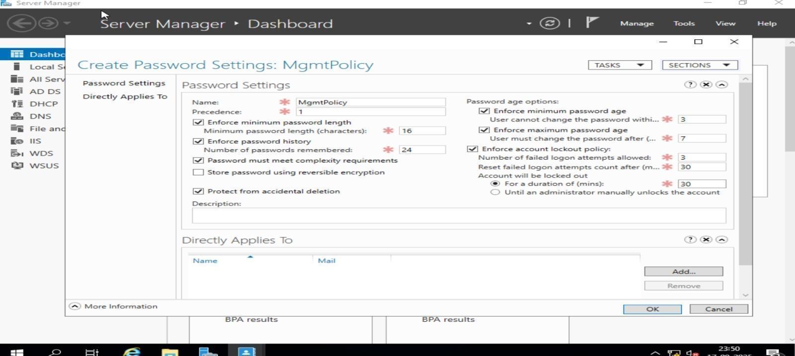
Figure 1.2
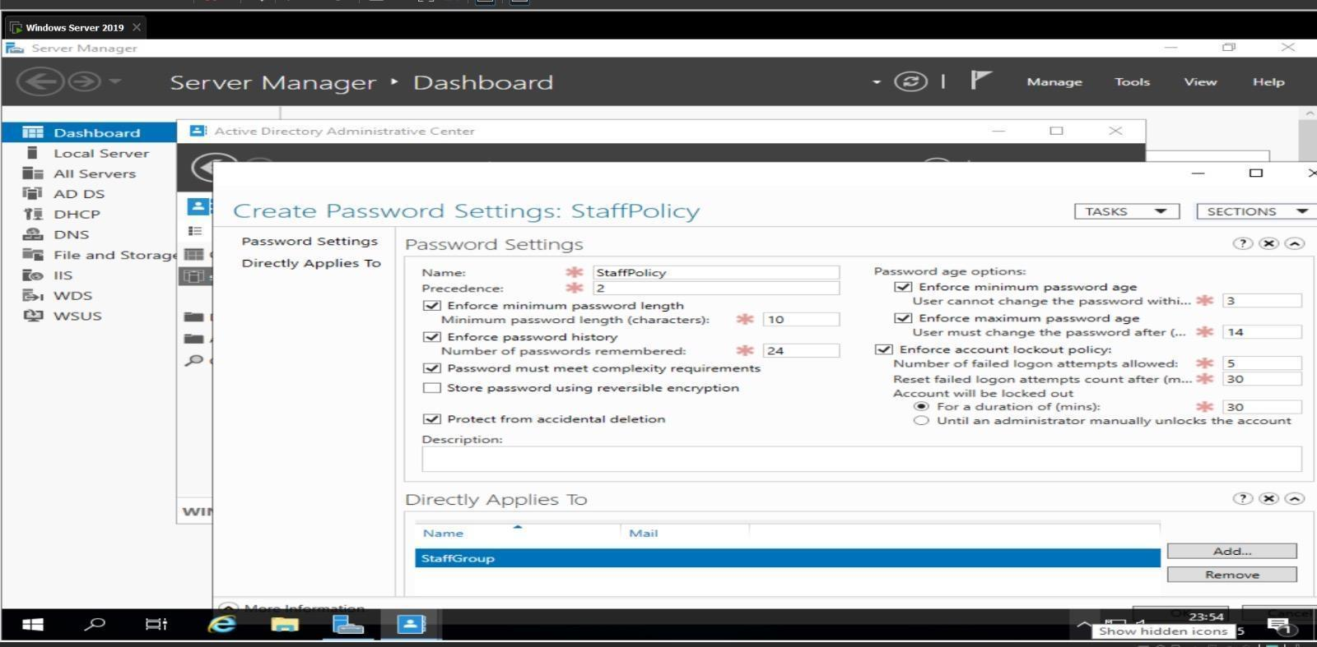
Figure 1.3
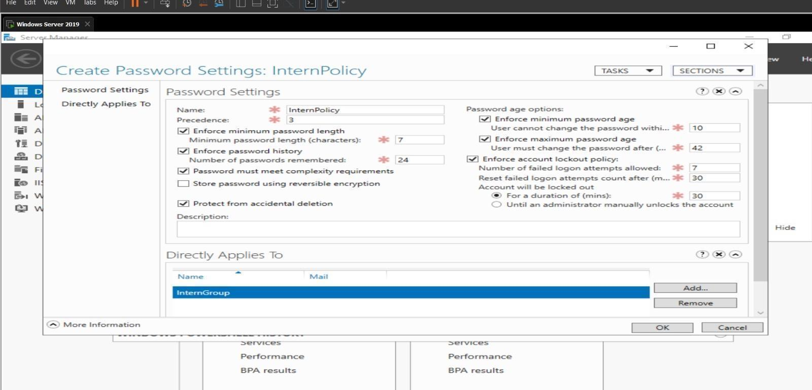
Figure 1.4
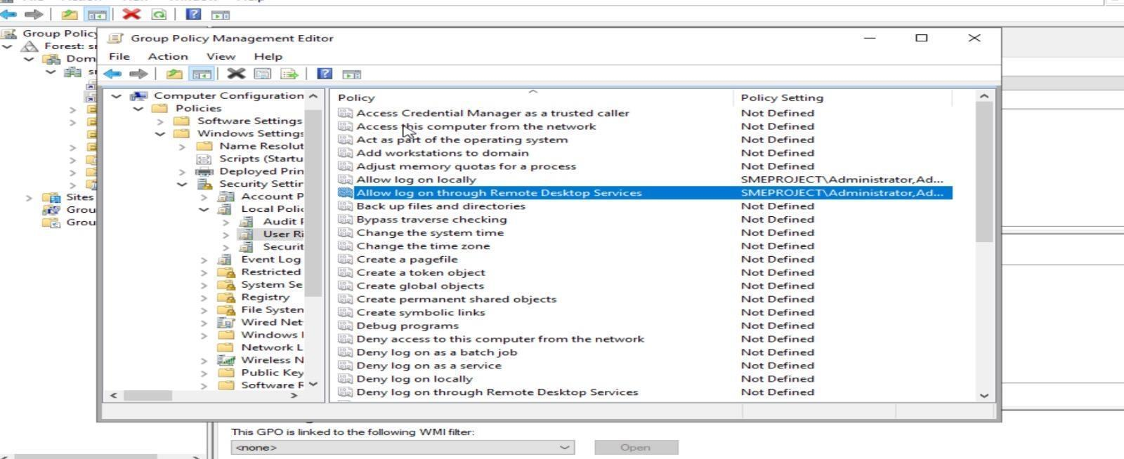
Figure 1.5
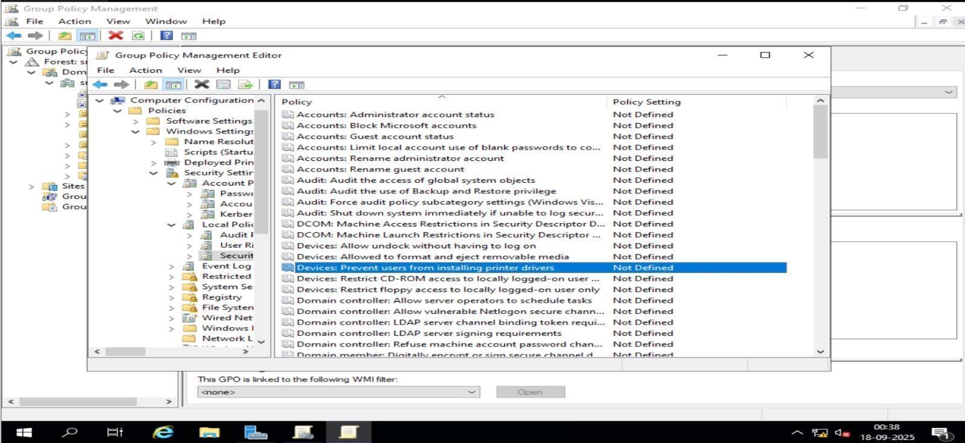
Figure 1.6
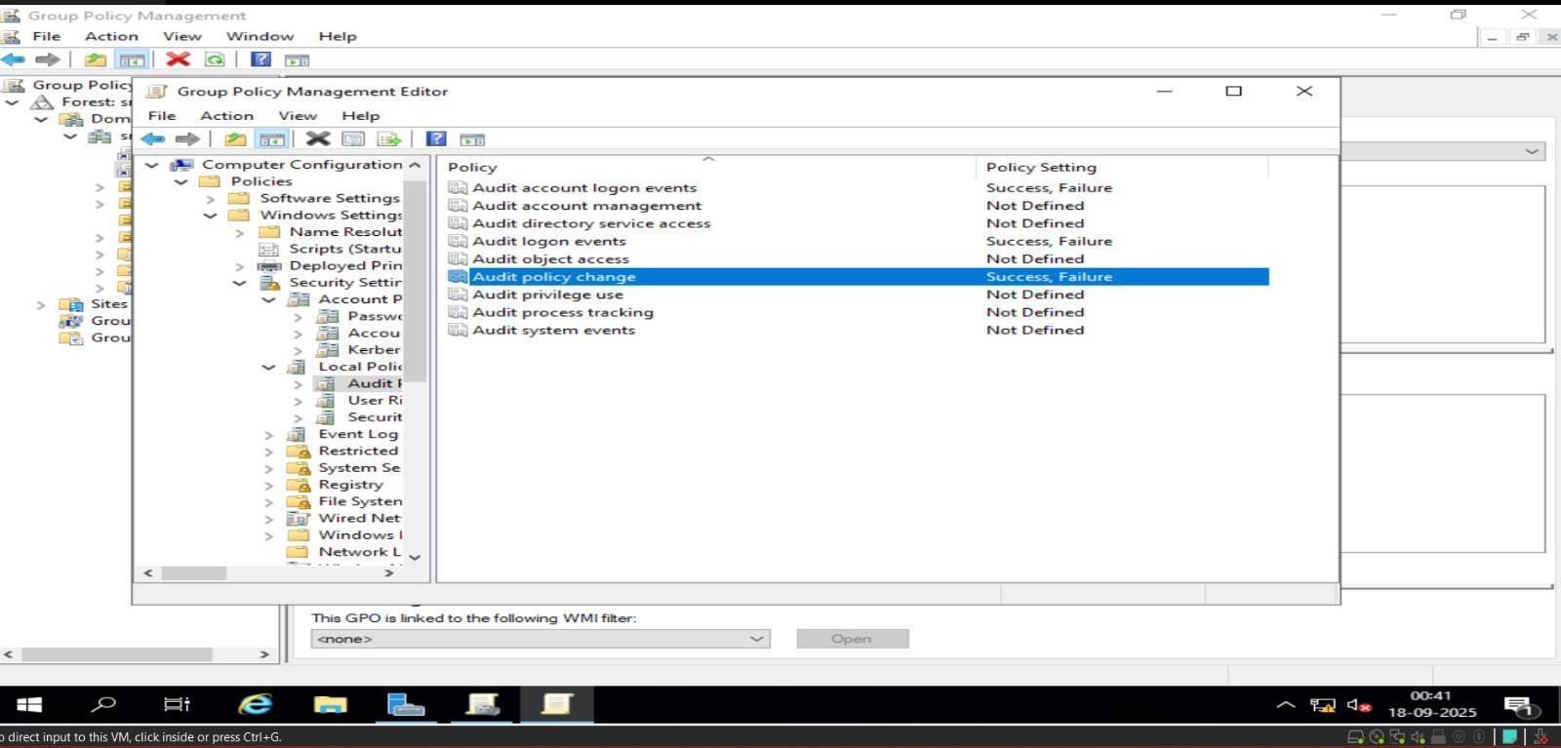
Figure 1.7
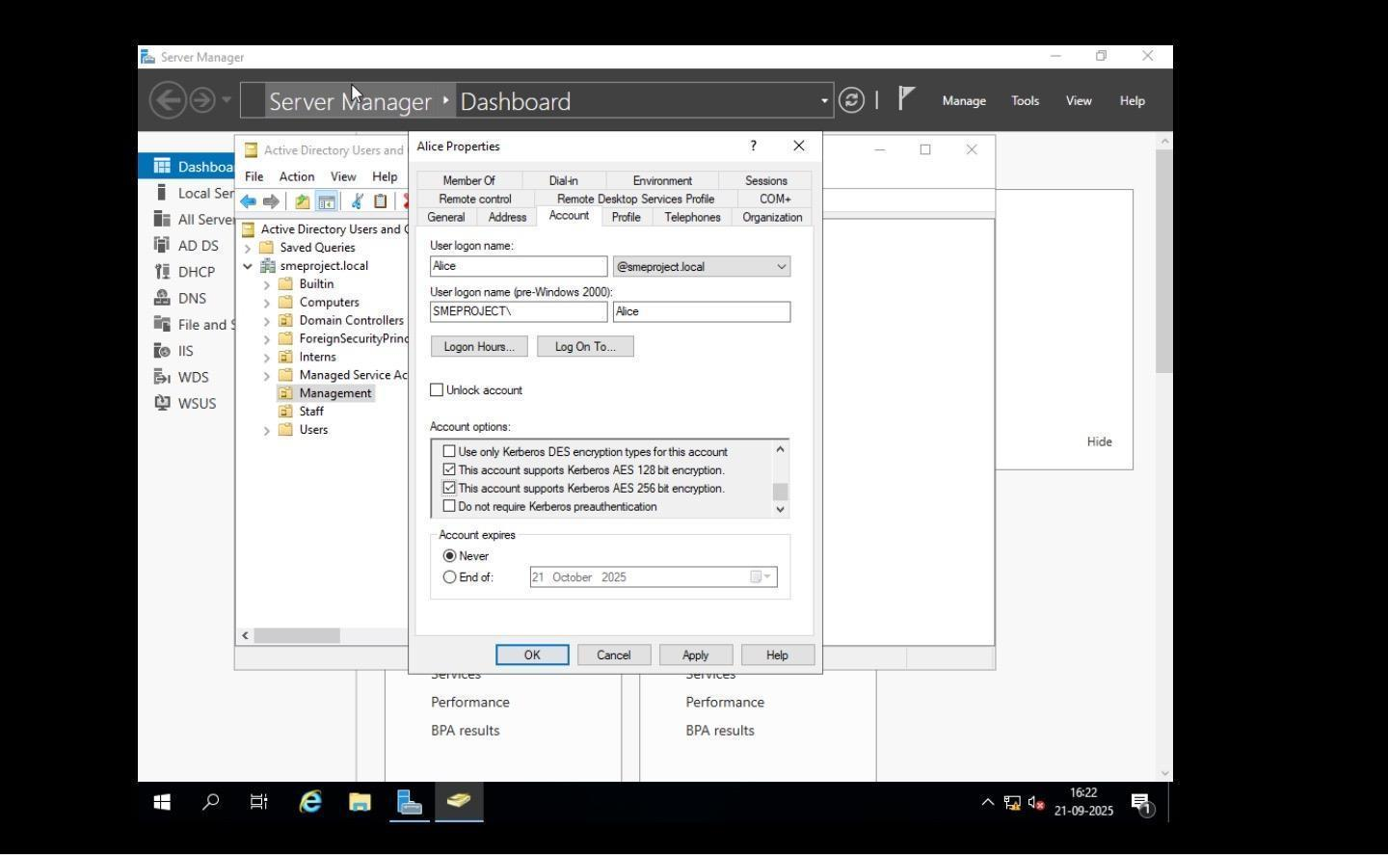
Figure 1.8
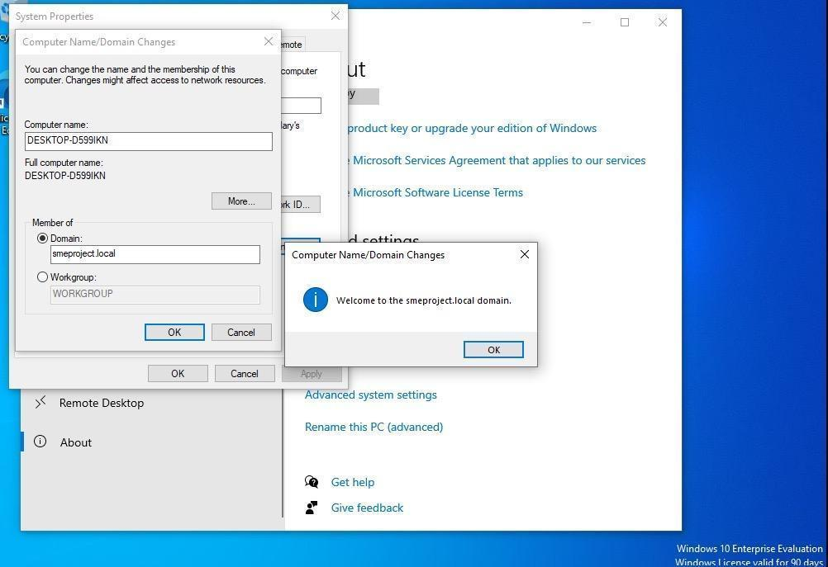
Figure 1.9
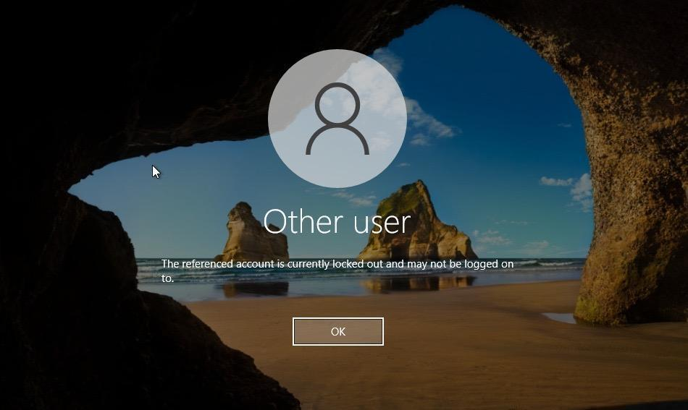
Figure 1.10
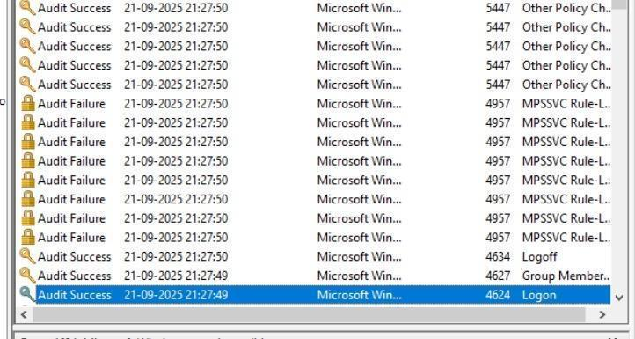
Figure 1.11

